NCA can be used to perform supervised dimensionality reduction. The input data are projected onto a linear subspace consisting of the directions which minimize the NCA objective. The desired dimensionality can be set using the parameter n_components. For instance, the following figure shows a comparison of dimensionality reduction with Principal Component Analysis (PCA), Linear Discriminant Analysis (LinearDiscriminantAnalysis) and Neighborhood Component Analysis (NeighborhoodComponentsAnalysis) on the Digits dataset, a dataset with size.

**[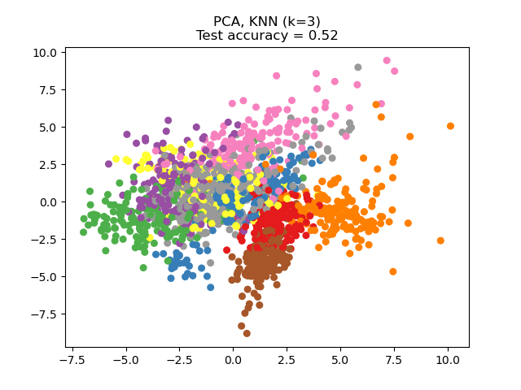](https://scikit-learn.org/stable/auto_examples/neighbors/plot_nca_dim_reduction.html) [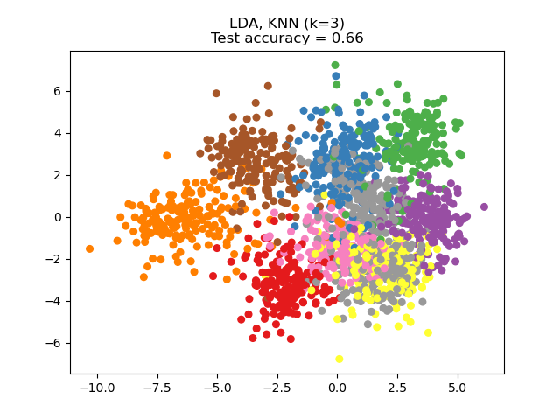](https://scikit-learn.org/stable/auto_examples/neighbors/plot_nca_dim_reduction.html) [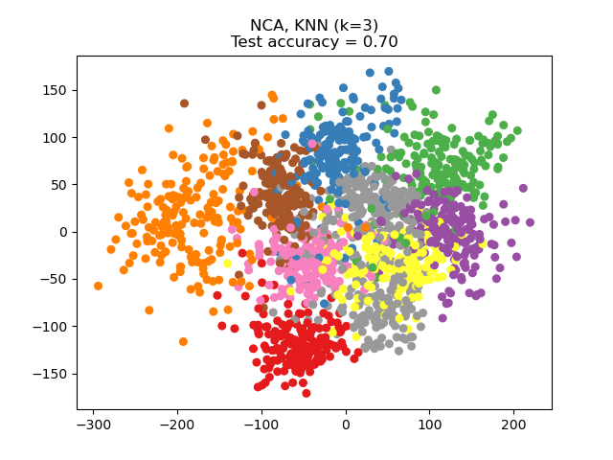](https://scikit-learn.org/stable/auto_examples/neighbors/plot_nca_dim_reduction.html)**

The data set is split into a training and a test set of equal size, then standardized. For evaluation the 3-nearest neighbor classification accuracy is computed on the 2-dimensional projected points found by each method. Each data sample belongs to one of 10 classes.